TYPICAL SIMIAN TASKS

CARTS
Carts are a convenient way of grouping several commands or audio files into one task with a friendly name. In order to build a cart, open up the event builder and select the cart icon:

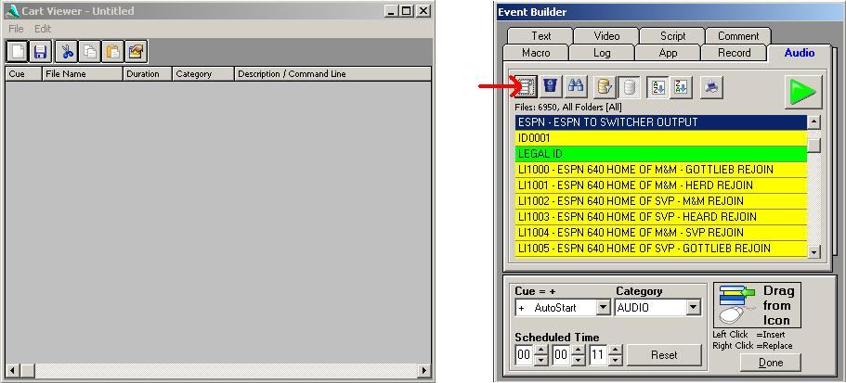

Left click select a file or event in the list in order to highlight it. Left click on the “Drag From Icon” and drag the green arrow into the Cart Viewer box. If you need to place a Macro into the cart, select the Macro tab in the event builder and select the needed macro in the drop down:

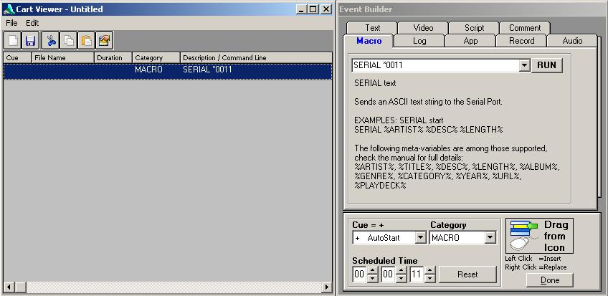

The first event in a cart will always AutoStart, which is why the AutoStart “+” is not displayed in the Cue column. For following events, AutoStart can be selected in the Cue drop-down in the event builder.

In the following Cart, the first four events will play automatically. The cart will stop playing when it reaches the fifth event because there is no AutoStart “+” in the Cue column. The next time this cart is called, it will start with the fifth event and play until it reaches the ninth event. Since this is a liner cart that plays over a network bed, both audio input 1 and audio input 2 are sent to audio output 1. Audio input 3 is turned off.

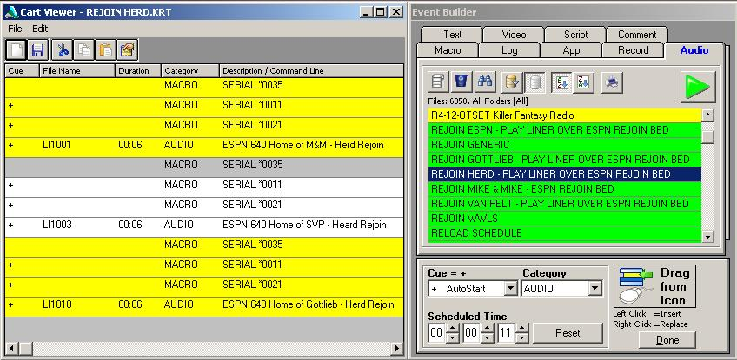

SOME USEFUL MACRO’S

Send Audio Input 1 to Audio Output 1: SERIAL *0011
Send Audio Input 2 to Audio Output 1: SERIAL *0021
Send Audio Input 3 to Audio Output 1: SERIAL *0031
Turn off Audio Input 1: SERIAL *0015
Turn off Audio Input 2: SERIAL *0025
Turn off Audio Input 3: SERIAL *0035
Pulse Switcher Relay 1: SERIAL *0OR1P
Pulse Switcher Relay 8: SERIAL *0OR8P

TRIGGERS
Triggers tell Simian what to do when it receives a satellite closure from the switcher. This can be edited from the toolbar at the top:
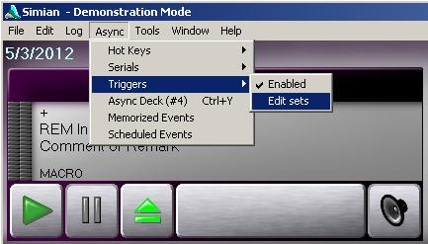

Below is a typical trigger set:
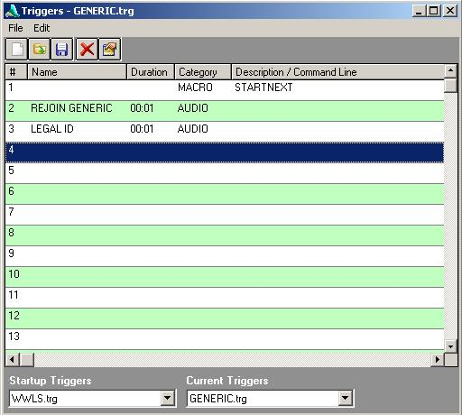

A closure on pin 1 will cause the automation to start the next event in the playlist. A closure on pin 2 will play a cart called “Rejoin Generic”. A closure on pin 3 will play a cart called “Legal ID”.
These events can be edited by drag and drop from the Event Builder.

Triggers must be enabled in order to act upon a closure, and they operate independently of the scheduled playlist!! When enabled, a trigger will execute even when the automation mode is in “Assist” or “Off”. Triggers can be enabled or disabled by selecting the “On” or “Off” icon in the bottom toolbar.

In order to customize the actions of satellite closures according to dayparts, different trigger sets can be called in the playlist. This is accomplished using the “LOADTRIGGERS” macro command:
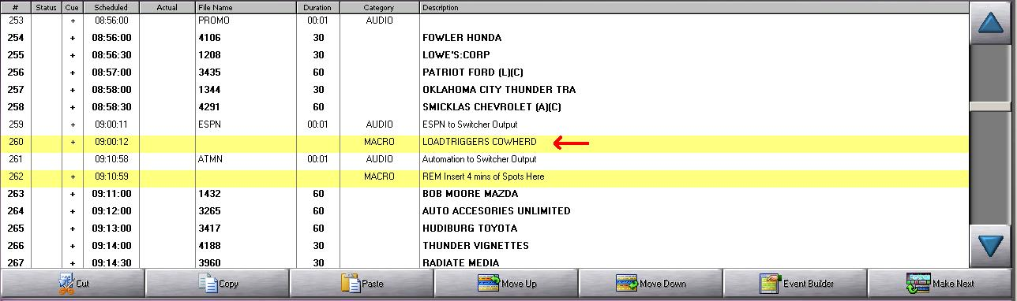

This loads the trigger set called Cowherd:
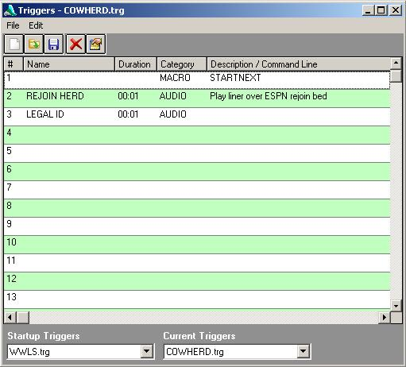
This trigger set differs from the “Generic” trigger set on closure 2. The cart “Rejoin Herd” is now played when closure 2 is detected.

HOT KEYS

Hot keys give a quick one-button access to commonly used carts, macros, and audio files.
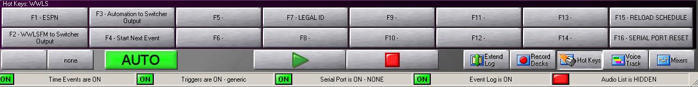

These can be edited from the top toolbar:
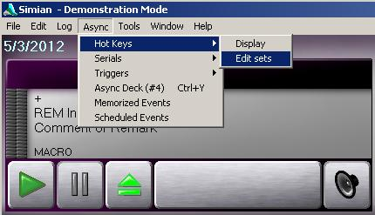

The hot keys can be edited by drag and drop from the Event Builder: